14th May 2013

**Significant Participation of YOKOHAMA at the Tuning World Bodensee**

*Great car line-up and exciting support programme*

The 11th edition of the Tuning World at Bodensee, Germany, took place from the 9th – 12th May 2013 and YOKOHAMA was again presented in various areas. The Japanese tyres were not only available on YOKOHAMA´s main booth but also in many hotspots all over the fair and on many car models of its partners like Lorinser, Piecha, Brabus and Ritter Cars as well as Lancia, Fiat and Alfa Romeo.

A diversified support programme accompanied the exhibition of YOKOHAMA. The Off-Road-Parcours at the outside area of the fair and the new event ”Turn the LEAF“ amazed the spectators. In cooperation with Nissan and Radio7, people had the opportunity to turn the electric car Nissan Leaf as efficiently as possible on a limited area.

It is already a tradition that YOKOHAMA nominates the winner for the YOKOHAMA 4x4 Award in cooperation with AUTO Bild Allrad. The jury judged an ABT Volkswagen Tiguan as the most impressive tuned SUV vehicle. Second place went to Carlsson CD35, followed by MTM Audi Q3 2.0 TFSI.

As in other years passenger cars were also awarded with distinctions during the European Tuning Showdown. 64 cars from 11 nations battled in Friedrichshafen in the Show & Shine contest. It took 6 qualification rounds to find the top three tuning cars. Johan Eriksson´s Dodge Charger R/T was chosen as the best show car 2013. All competitors had furthermore the opportunity to take place in the YOKOHAMA Tuning Award.

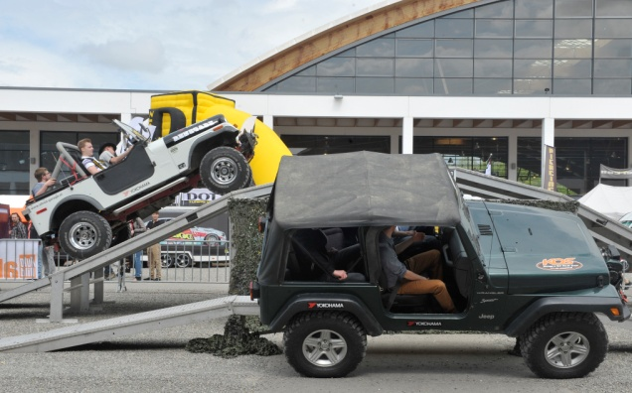The internet-competition that YOKOHAMA started in the context of the Tuning World Bodensee will go on until 31st May 2013. 30 attractive prizes are available to the winners. The short movie and the competition-question are available at <http://www2.yokohama-online.com/de/gewinnspiel/gewinnspiel.php>